Homework 2 – BSCI370

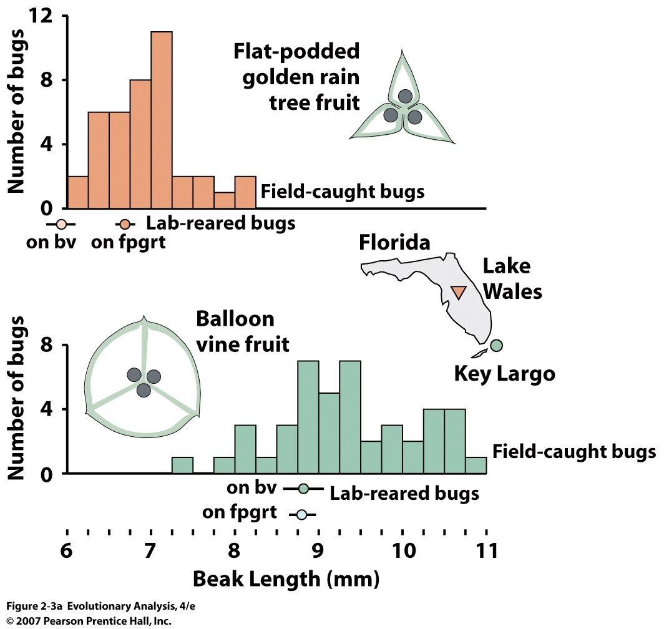

1. What does the above figure illustrate about soapberry bug evolution? How do natural selection, mutation, gene flow, and descent with modification each play a role in this system?



1. The above graph illustrates the relationship between height in parents and offspring of Rhinogrades (a tropical mammal). What statement can be made about the heritability of height? Can you say whether height is under genetic control? Why is heritability important for Darwinian natural selection?